Project 1 Report

Name: Xujia Qin

**Required image 1**

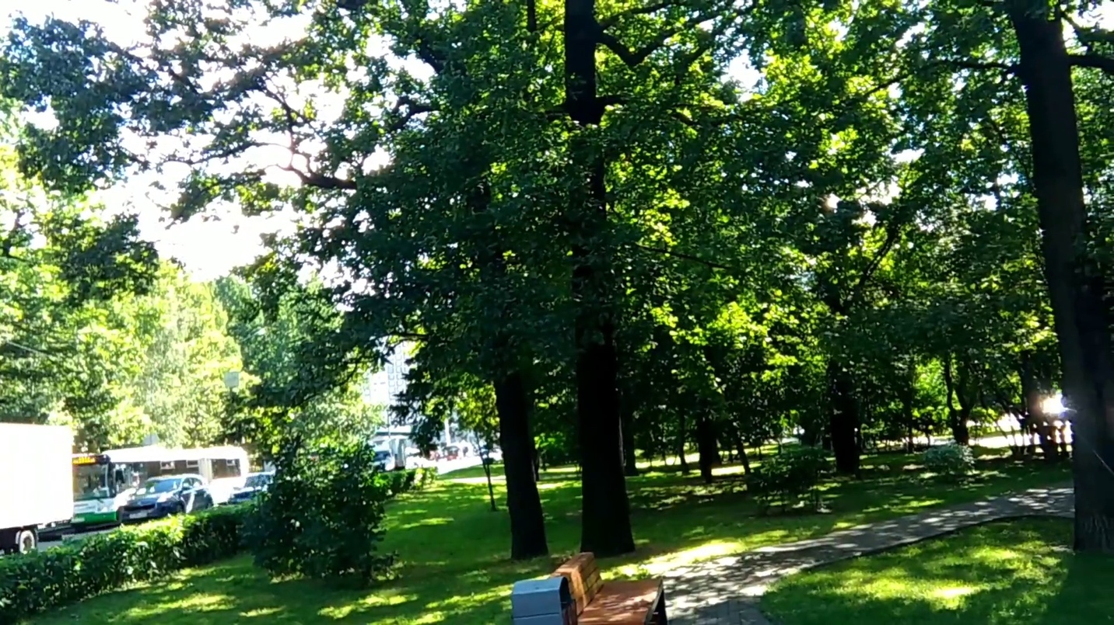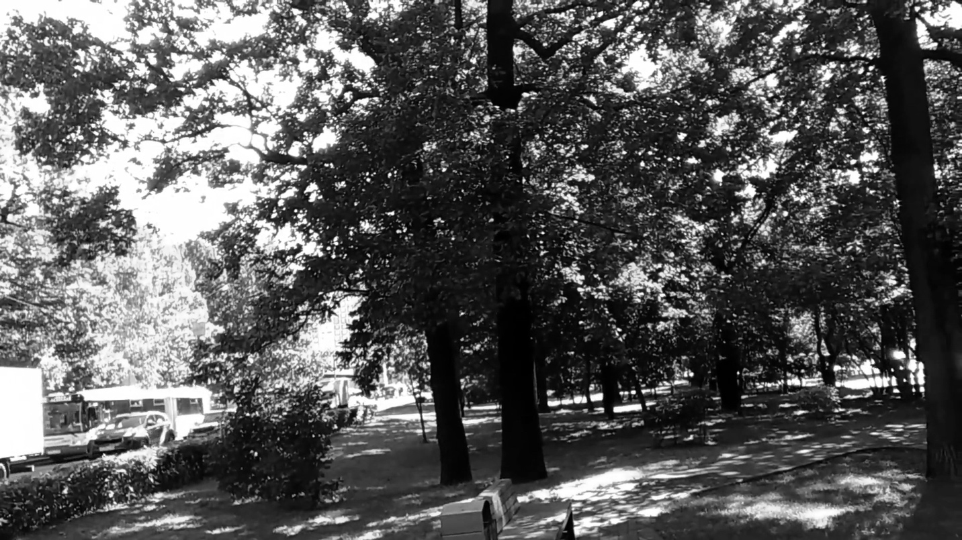

**Required image 2**

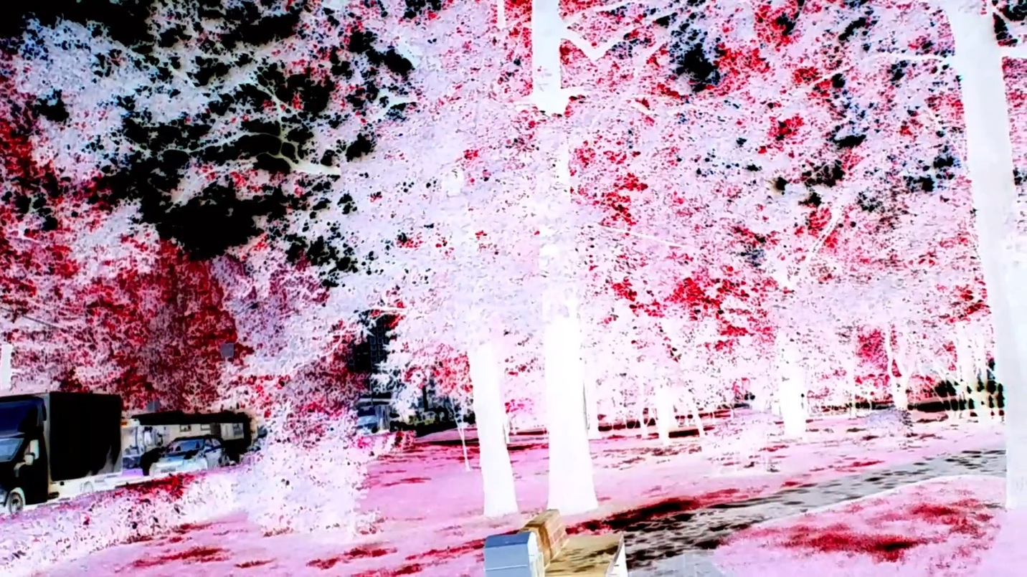

To generate the grayscale version, I used a color inversion method rather than the typical weighted average of the RGB channels.

For each pixel: Red, Green, and Blue channels are inverted: r = 255 - pixel[2], g = 255 - pixel[1], b = 255 - pixel[0].

Differences from Default Grayscale:

Brightness: The default grayscale preserves brightness, while the inverted method alters brightness, resulting in complementary color contrasts.

Color: Default grayscale converts to shades of gray, whereas the inverted method keeps the complementary colors (e.g., red becomes cyan).

**Required image 3**

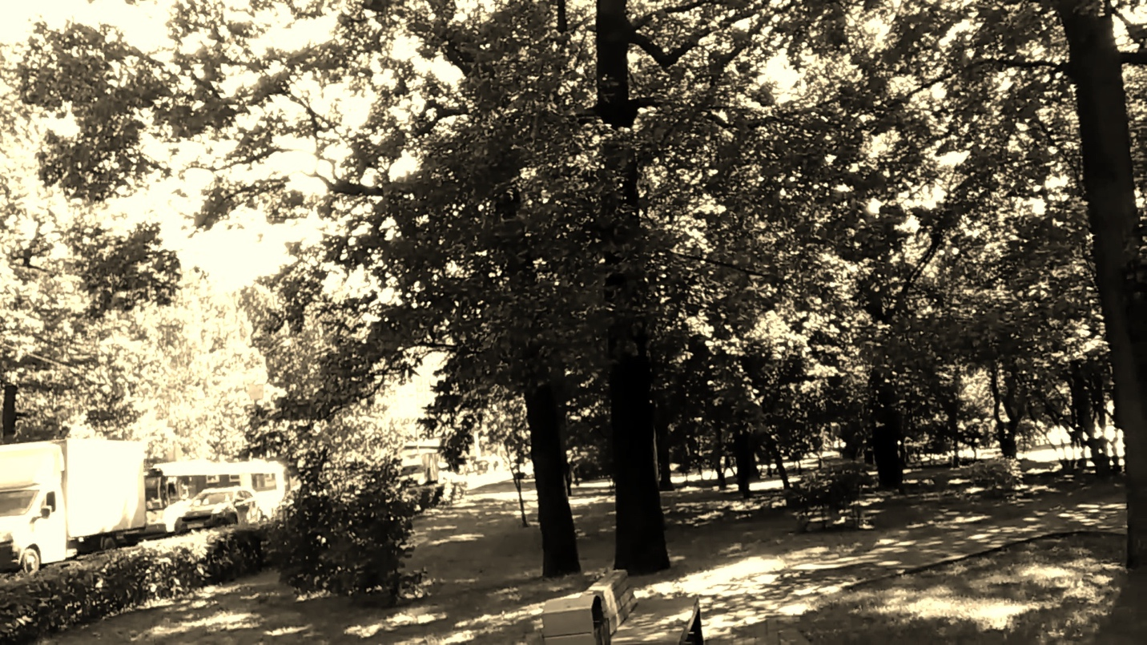

To ensure the computation uses the original RGB values, the code reads the source pixel values (B, G, R) before any computation, ensuring transformations are based on unmodified values. Each new channel value (newB, newG, newR) is computed independently without relying on intermediate results.

**Implement a 5x5 blur filter**

1. Time per image (1): 0.2296 seconds
2. Time per image (2): 0.1381 seconds

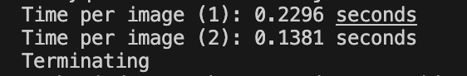

Why the 2nd method it’s faster:

I use separable filter 1*5 and 5*1 matrix to implement the blurring, so that it can reduce the operations compared with the 5 *5 Gaussian blurring.

From (25 + 24 + 1) = 50 ops per pixel reduce to (5 + 4 + 1) * 2 = 20 ops per pixel.

**Required Image 4:** the blurred image

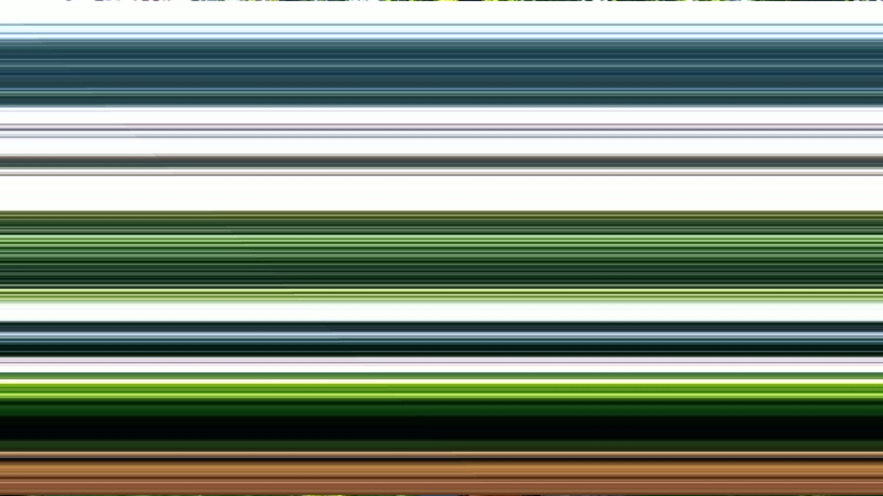

**Required Image 4:** gradient magnitude image from the X and Y Sobel images

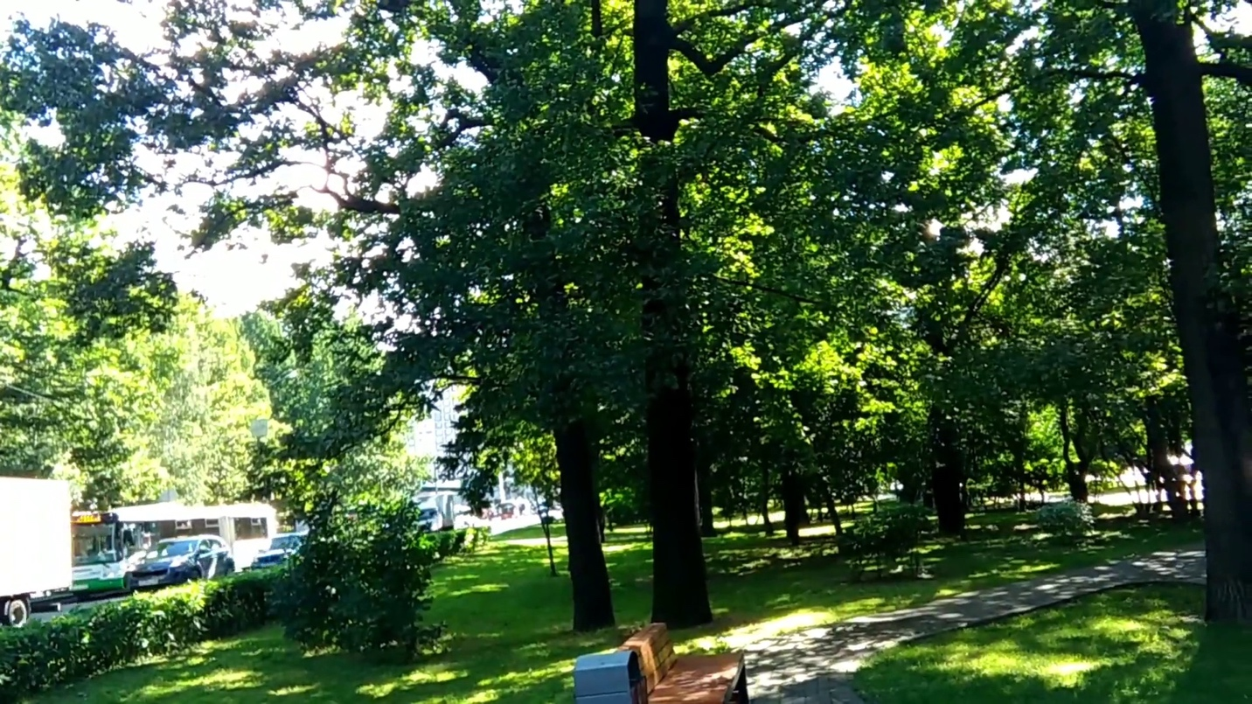

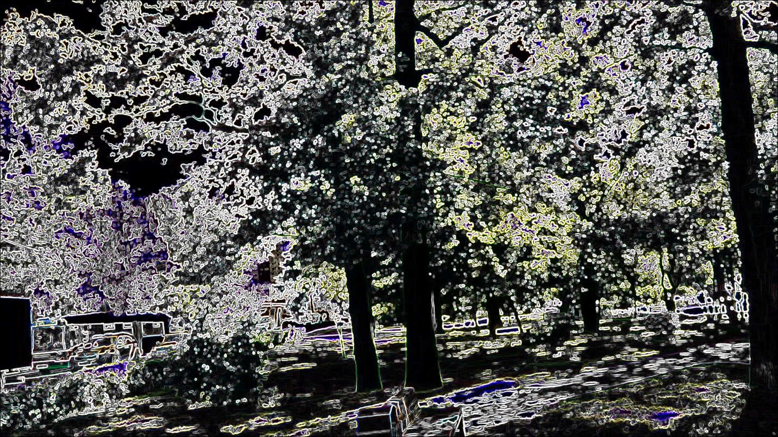

**Required Image 5: blurs and quantizes a color image**



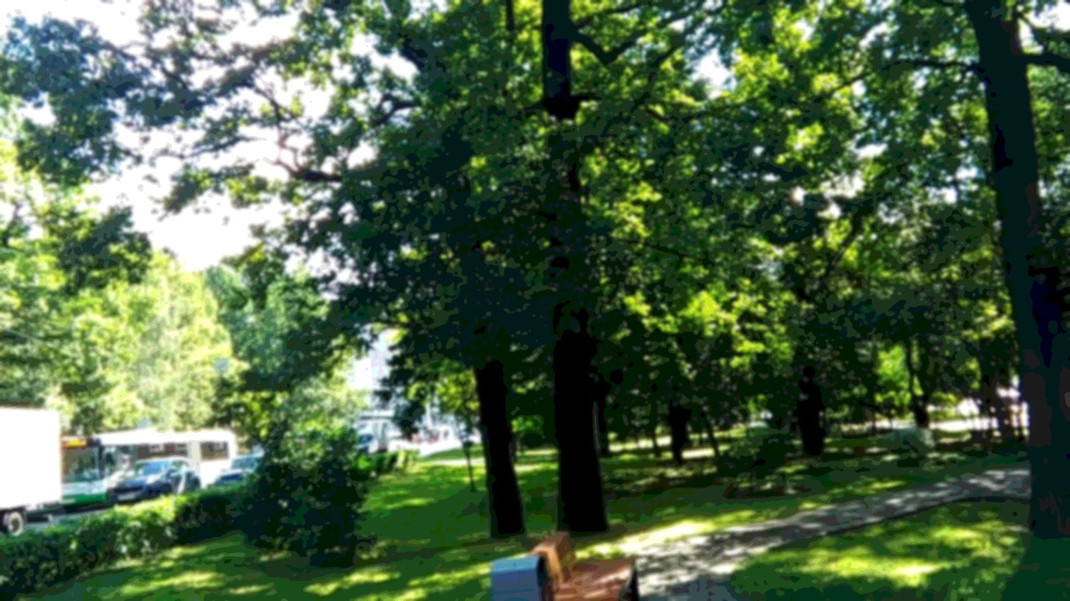

**Required Image 6: face detected**

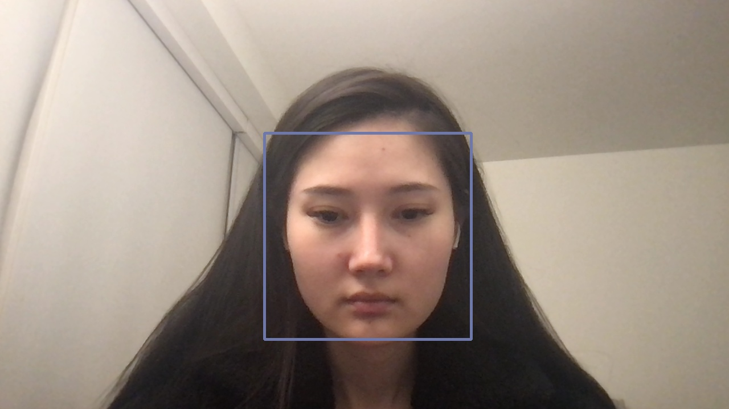

**Required Images 7: a depth image from my video stream**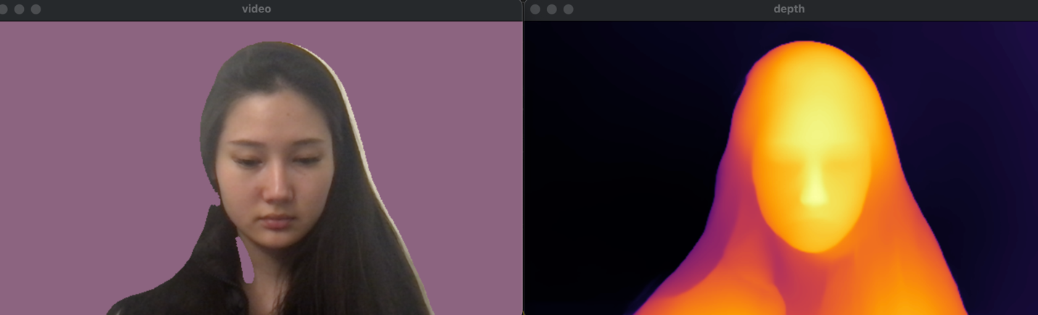

**Required Images 8: an image of sepia tone filter using depth values**

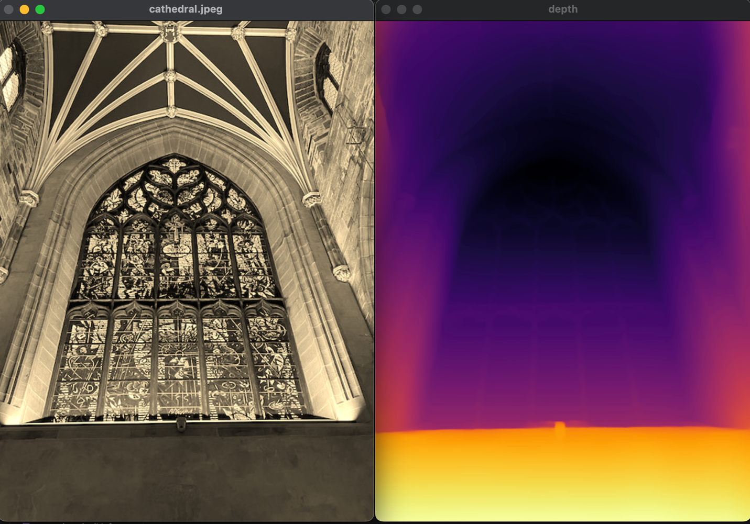

**scale depth values by 5**

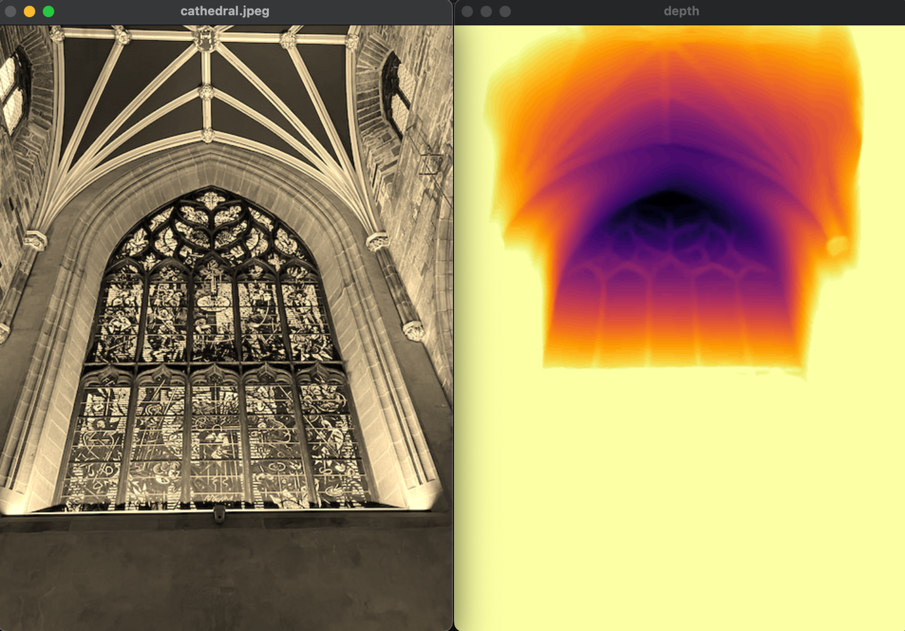

**Required Images 9-11:**

**Cartoon effect:**

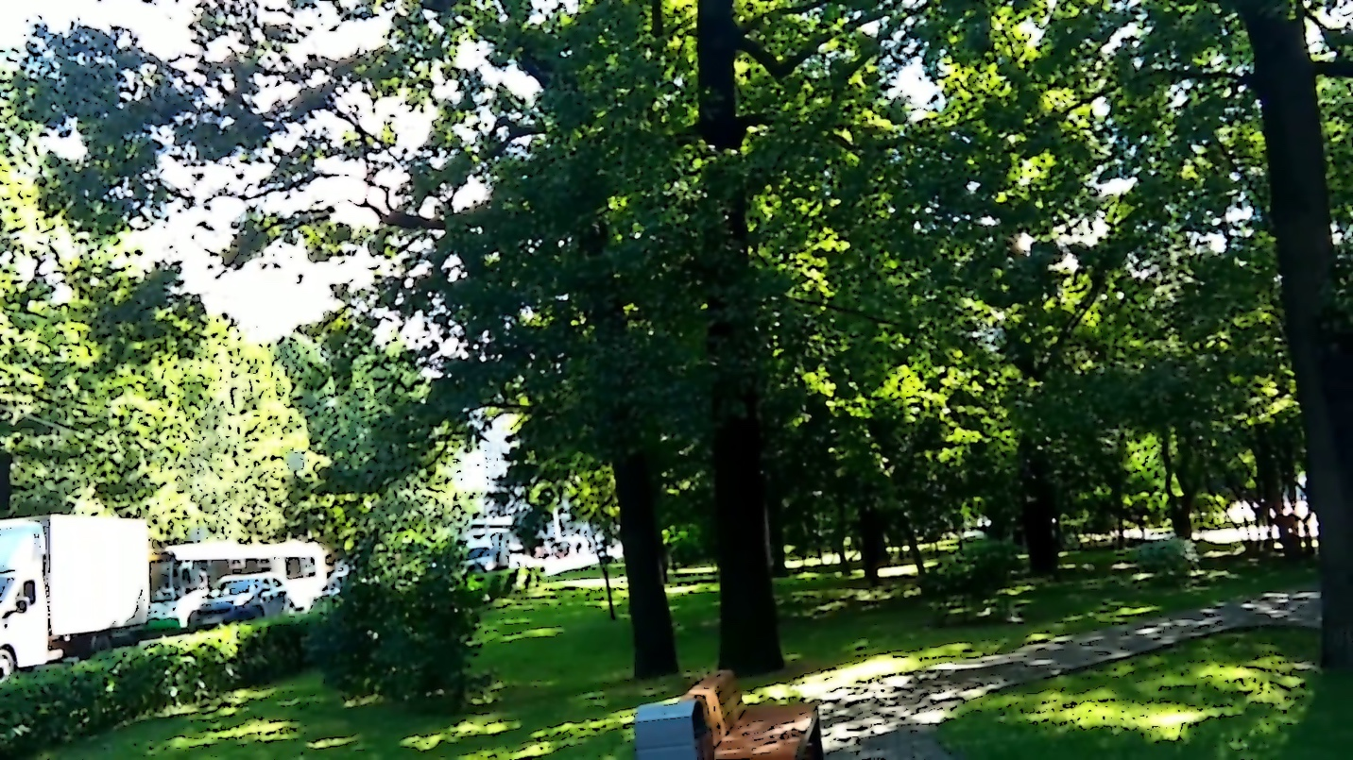

**Emboss effect:**

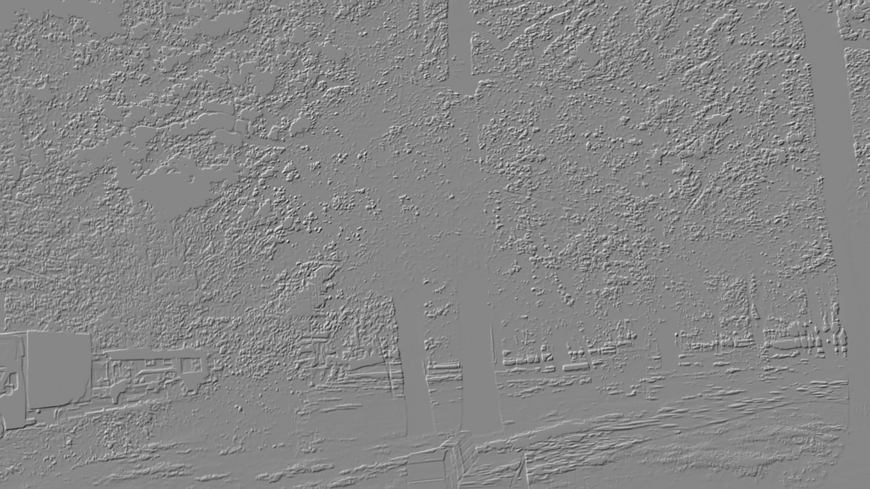

**Face blurred effect:**

